Syed Abdul Rahim

sarpsl@gmail.com

Semantic Spotter 2.0

Project Report

Contents

Project Goals 2

Data Sources 2

Document Source: 2

Design Choices 2

Framework Choice: 2

Document Parsing: 2

Vector Storage: 2

Query Processing: 2

Integration with LLM: 3

Challenges Faced 3

Complexity of PDF Documents: 3

Indexing Efficiency: 3

Query Accuracy: 3

Flowchart 3

Setup 4

Usage 4

Import Libraries: 4

Run the Script: 4

Query the System: 4

Sample Run: 4

Use Case: 4

Chat Conversation: 5

Troubleshooting 6

PDF Parsing Issues: 6

Indexing Errors: 6

## Project Goals

This project aims to create a document processing and query system using LlamaIndex with an HDFC Policy PDF as the source document. The goal is to build a system that can parse complex documents, extract relevant information, and provide user-friendly responses to queries. By leveraging LlamaIndex, we aim to efficiently index and query document contents, offering a scalable solution for handling policy documents and similar texts.

## Data Sources

Document Source: HDFC-Life-Group-Term-Life-Policy PDF

Purpose: The HDFC Policy PDF serves as the primary data source for this project. The document contains detailed information about insurance policies, which will be parsed and indexed.

Format: PDF

Content: Policy terms, conditions, coverage details, and other relevant sections.

## Design Choices

Framework Choice: LlamaIndex is chosen for its capability to handle document parsing, indexing, and querying efficiently. It integrates well with various vector storage solutions and provides a robust querying engine.

Document Parsing: The PDF is parsed into structured data using LlamaIndex’s `SimpleNodeParser`. This choice allows us to handle complex documents with multiple sections and formats.

Vector Storage: For simplicity and to maintain local control, the vector storage is handled directly within the LlamaIndex framework without external databases.

Query Processing: The system uses LlamaIndex’s querying capabilities to search through the indexed document and retrieve relevant information based on user queries.

Integration with LLM: While not required in the current implementation, integration with a Language Model like OpenAI's GPT could be considered for enhanced interaction and natural language understanding.

## Challenges Faced

Complexity of PDF Documents: Parsing PDFs can be challenging due to the complex layout and varied formatting of documents. Ensuring that all relevant information is accurately extracted and indexed required careful handling.

Indexing Efficiency: Efficiently indexing large documents while maintaining performance and accuracy was a key challenge. Optimizations were needed to balance indexing speed and query performance.

Query Accuracy: Ensuring that the query results are accurate and relevant required fine-tuning of the parsing and indexing processes. Handling different types of queries and ensuring correct results involved iterative testing and adjustments.

## Flowchart

A flowchart illustrating the system design and various layers of the project:

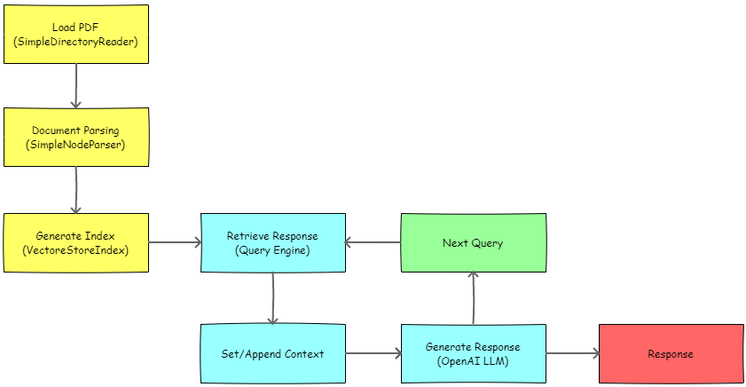

## Setup

1. Place the HDFC Policy PDF file in the project directory.

2. Update the PDF path in the code if necessary.

## Usage

### Import Libraries:

If it’s a fresh environment or the libraries aren’t installed, then uncomment the first ‘pip install’ cell block and execute to get those libraries installed in your environment.

### Run the Script:

It’s a Jupyter notebook, feel free to open in your favourite editor, like VS Code or Google Collab and do Run All

### Query the System:

Enter queries related to the HDFC policy to receive relevant information from the document.

## Sample Run:

### Use Case:

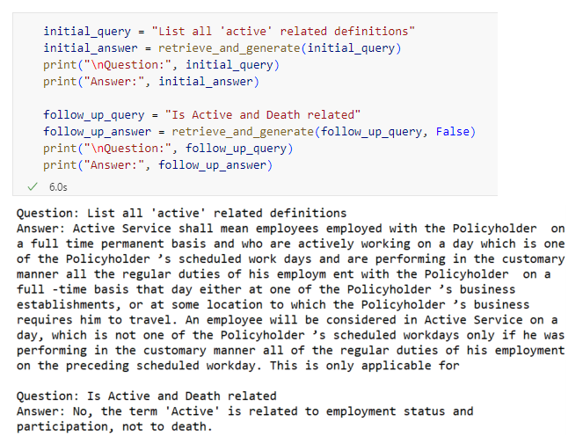

### Chat Conversation:

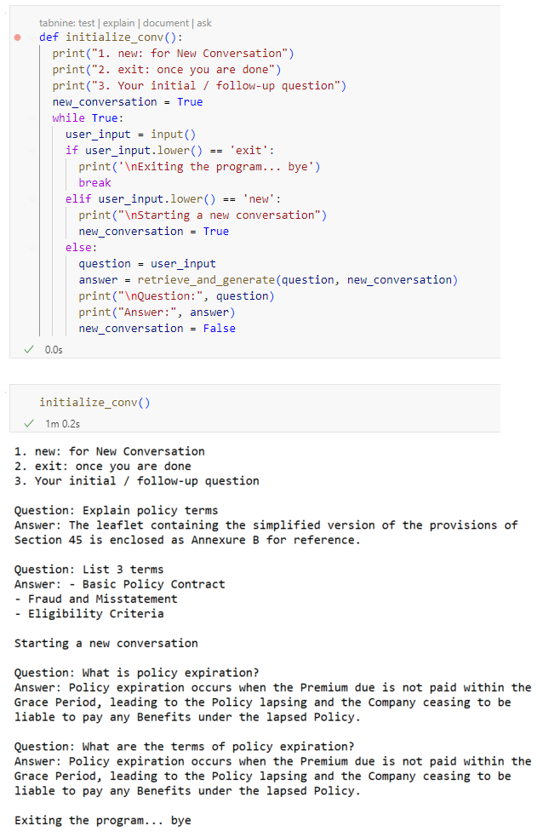

## Troubleshooting

PDF Parsing Issues: Ensure the PDF is correctly formatted and accessible.

Indexing Errors: Verify that all dependencies are correctly installed and configured.

[End of Document]